Technology & Social Isolation Sections III, IV, and V

Anthony Meunier

DeVry University

Technology & Social Isolation Sections III, IV, and V

Technologies are changing the ways that people are interacting with and interpreting the world around them. In current day, we are constantly seeing an integration of technologies into all facets of daily life. This integration is often aimed at evolving or enhancing the way we conduct daily tasks, such as learning and/or conducting business affairs. Children now grow up using and being taught via technologies, which has a significant impact on their perception of themselves and their interactions with others. Recently in my home county of Los Angeles there was rollout of a 1 billion dollar plan that aims to provide every teacher and student with an iPad that is meant to enhance and change the ways they conduct classes and learn information. This type of integration that introduces technologies into the classroom is just an expansion of what is already happening in the home. According to Cenameri (2013), “77% of 13-16 year olds and 38% of 9-12 year olds in the European Union have a profile on a social networking site” (p. 571).

While it has been acknowledged that technologies do have the potential to be powerful tools for learning, Cenameri (2013) noted that technology use must be monitored carefully from an early age or an adolescent may run the risk of becoming addicted to technologies, causing them to become socially isolated as well as becoming detached from reality. By using technologies, people are placing themselves into a situation in which human nature may ultimately get the best of them. It’s how we choose to use technologies that determines their effectiveness, or can instead shape unhealthy habits.

In my own experiences, technology has had a deeply profound impact on the way my own social skills and habits have developed. Being a “child of the Internet,” I have spent most of my life glued in front of a computer monitor, TV display, or cell phone screen. The ease of access and common-nature of these devices has given me great satisfaction and always allowed me to feel preoccupied. These technologies have also, simply, made my life easier and more comfortable by allowing me to accomplish a great deal (shopping, entertainment, communication) when it is convenient for me. Gordon (1990) proposed that the “cocooning” this reliance creates keeps people from interacting with each other, and only as I have grown older have I finally been able to realize that all the hours spent on and using these technologies have really led me nowhere and done nothing to prepare me to succeed in “real life.”

Due to technologies having been the predominant time-filler in my own life growing up, I can attest to the studies conducted by Massimini and Peterson (2009) and also boldly say that I, much like their test subjects, now prefer methods of communication via ICT. I simply cannot be bothered with attending social events or even making a phone call to catch up with a close relative. Massimini and Peterson’s (2009) results indicate “almost half of the sample (47.3%) agreed with the statement ‘I use text messaging, e-mail, instant messaging, Facebook or MySpace to avoid talking to someone directly (phone call or face-to-face)’” (p. 4). Technologies simply allow me to control the time and nature of conversations and I am constantly *mis*using them in order to not be troubled to leave the comfort of my own home. What this has really done for me though is it has caused my social skills and relationships to suffer, because I continuously choose to not go out and partake in real life. Through the power of technologies, I can access all the entertainment I need from home in order to combat loneliness and boredom, but still feel as though I have the capacity to stay connected.

The only true way for one to change this dependence on and preference for technologies is by becoming self-aware. Through my own admittance, and through the ideas presented in this text, I simply hope that one can begin to see the error of their ways. If you, like me, are constantly longing for a more genuine, and even more connected social experience, you must begin to distance yourself from the grasp of technologies. You must compel yourself to take the effort, on your own behalf, to be receptive to the opportunities that exist and are happening every day around you. As Vroon (2009) stated, “Anyone who wants to do something for the world or just amount to a decent human being has to stay away from these technologies as much as he can” (p. 54).

Figure 2: Internet Use & Extraversion with Community Involvement & Loneliness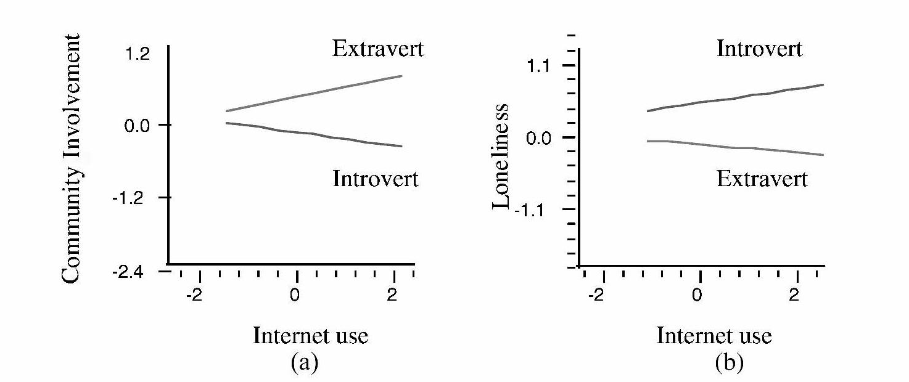

*Figure 2:* Graph (a) shows how increasing Internet use among extraverted users leads to more community involvement, but for introverted users more use leads to decreasing community involvement. Graph (b) indicates that increased Internet use among introverts leads to increased loneliness while extraverts experience slightly decreasing levels of loneliness as their Internet use increases. Source: “Internet Paradox Revisited” by Kraut, R., Kiesler, S., Boneva, B., Cummings, J., Helgeson, V., & Crawford, A., 2002, *Journal of Social Issues*, *58*(1), p. 61.

In today’s world, technology is sometimes a necessity. It is not entirely valid to expect the people of a first-world Superpower country to completely detach themselves from technologies. But as I’ve alluded to, it is all about how and when a person uses technologies that either makes them helpful or hurtful. With technologies now evolving into “all-in-one” solutions to peoples’ wants and needs, there is increasing exposure to the *distraction factor* that technologies often create for users. People need to learn how to distinguish the difference between wants and needs, and by doing so this will allow the users of technologies to more efficiently determine when and where the necessity aspect of technology fits into their lives. If we can learn to apply technologies in meaningful and helpful capacities, we can gain so much from there. If we do the opposite, technologies can take us away from the world around us and create a sense of loneliness and isolation.

When technologies begin to include so many aspects as is the case with all-in-one devices, the line begins to become blurred between efficiency and time-wasting. There are quite frankly just too many opportunities for humans to distract themselves when there are endless possibilities right at their fingertips. It is exactly this that is causing the deterioration of social society. We need to face the reality of what modern-day has brought us, and be mindful of the how these changes can, and are, impacting social habits and skills. Technologies are not going anywhere. They are only evolving and becoming more integrated into all aspects of our daily lives. In order for society to continue along with these advancements and salvage any hope of remaining *genuinely* socially-connected, we need to adhere to the principles of self-awareness and self-control. The ease of becoming distracted and detached is constantly present, but we need to remember a time in our history when going out to the movies or a drive-in theater were the preferred methods of entertainment, and not iPods with noise cancelling headphones (Cutchen, 2009, p. 10).

We as a society need to have the capacity to demand more from ourselves. More self-control needs to be exercised in order to use and apply technologies for purposes of efficiency and production rather than allowing ourselves to become detached and isolated due to the opportunities for distraction introduced by many technologies. I propose that true self-realization of technology intrusion and dependence can make users more selective about how to balance and manage their lives. Awareness is the first step to any type of change, and if people care to preserve and maintain a high level of social skillsets and interactions they would do well to make a proactive effort to change their newly formed, modern-day habits. This would lead to a much healthier and more meaningful life, as well as much stronger and more tight-knit societies.

References

Cenameri, M. (2013). Internet, Child and Adolescence Social Development. *Mediterranean Journal of Social Sciences*, *4*(2), 571-578. doi:10.5901/mjss.2013.v4n2p571

Cutchen, M. T. (2009). Parenting: Taking the Easy Way Out. *ETC: A Review of General Semantics*, *66*(1), 10-11.

Gordon, M. (1990, July). High-Tech Loneliness: How Our Inventions Keep Us Apart. *Futurist*. p. 60.

Kraut, R., Kiesler, S., Boneva, B., Cummings, J., Helgeson, V., & Crawford, A. (2002). Internet Paradox Revisited. *Journal of Social Issues*, *58*(1), 49-74.

Massimini, M. & Peterson, M. (2009). Information and Communication Technology: Affects on U.S. College Students. *Cyberpsychology: Journal of Psychosocial Research on Cyberspace, 3*(1), 1-12.

Vroon, D. (2009). The Distracted Generation Victims of Technology. *American Record Guide*, *72*(3), 53-54.